
1. Introduction (5 points)
The purpose of this project was to develop a Linux-based live response tool that automates the collection of forensic artifacts while preserving system integrity. During digital forensics, critical system information often needs to be gathered for data to be compromised or deleted.
This is why it is crucial to be able to efficiently collect volatile and non-volatile data from a live system in a repeatable and structured way. The live response tool focuses on identifying potential security threats and persistence mechanisms that attackers can use to access a compromised system. By automating artifacts and organizing outputs into a structured directory, the tool simplifies and accelerates the early stages of incident response and digital forensic investigations.

2. Technical Implementation:
This Linux Live Response tool was implemented using bash scripting on a Linux environment. Through the usage of bash scripting, it allowed for a direct interaction with the operating system and also allowed for access to administrative tools and already built-in forensics.
System Architecture:
Our Linux-based live response tool consisted of multiple scripts that collected various types of system data:
- collector.sh
  - Main script that executes all modules
  - Creates timestamped output directories
- System_info.sh
- Collects system details using:
  - uname
  - hostnamectl
  - timedatectl
  - lscpu
  - Free

  - users_auth.sh
- Gathers user and authentication data:
  - who
  - last
  - /etc/passwd
  - Bash history files
processes.sh
- Captures running processes and services:
  - ps aux
  - lsmod
  - systemctl list-units

network.sh
- Collects network-related information:
  - ss -tulnp
  - ip addr
  - ip route
logs.sh
- Extracts system logs:
  - /var/log/auth.log
  - /var/log/syslog
  - journalctl
persistence.sh
- Detects persistence mechanisms:
  - Cron jobs (user and system)
  - Systemd services and timers
  - Startup scripts
  - SUID/SGID binaries
Techniques:
Many techniques were used and mainly to create a structured output organization, as well to automate repetitive tasks, preserve forensic integrity through data collection and the usage of a command line forensic analysis. All these tools were used to be able to replicate a real-world incident response that created a reliable, fast and low overhead access to system data.
Results:
The tool was able to generate a structured output folder containing categorized forensic data that is crucial. Through this structured approach it helps investigators be able to locate and analyze relevant data. The tool improves efficiency, supports a more streamlined investigative workflow. Tools ensure that data is easier to be viewed and not overlooked during the initial phase.
Subfolders are structured by:
- logs/
- persistence/
- processes/
- system/
- users/
Key Outcomes:
- Organized and structured data
- Direct identification of any potential persistence techniques
- Gives a collection of system artifacts within seconds

3. Results (5 points)
The results of the
Cron jobs:
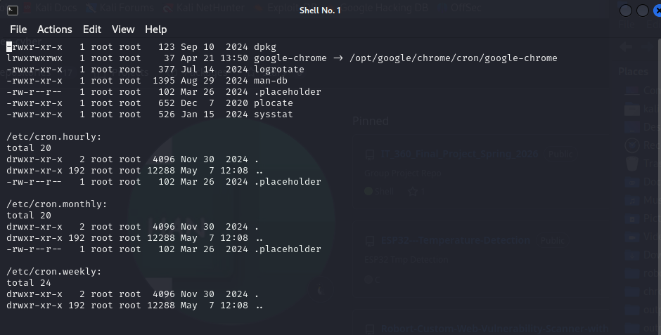
Systemd:
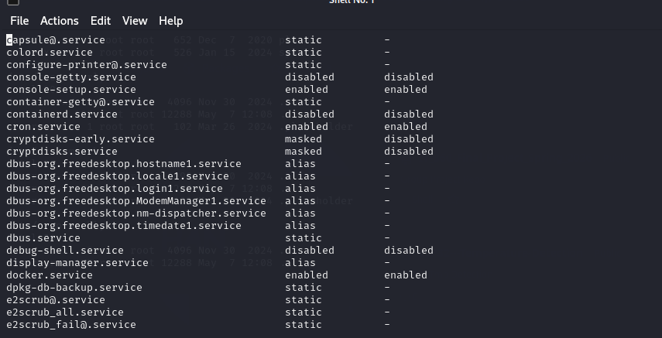

4. Lessons Learned & Conclusion (10 points)

